**Danger log**

**-----cz125, ny38**

**1.25** We decide to limit at most one sharer per ride, otherwise the owner’s benefit will be badly threatened.

**1.28** ~~We find that after driver confirm the ride, it is inappropriate to let passenger still be able to edit.~~ (fixed on 2.1)

**1.31**

1. If a ride-owner is a part of a ride and click “go back” and request another ride at the same time or in the same time window, our website cannot detect it, nor would give any warnings.
2. ~~A user can request a ride and log out and login again as a driver to claim rides.~~ (fixed)

To prevent time conflict happening, we decide to limit the visit’s role as user or driver at one time until all the involved ride on one side has been completed.

1. ~~Cannot update pages automatically. (Cannot navigate to home page after the completion of a ride.~~ (fixed on 2.1)
2. Tested website on mobile devices and works perfect.

**2.1** To prevent illegal edition and no page refresh, we fix it by adding automatic webpage replace on user/sharer editing page with status view page. And after driver complete the ride, status view page will jump back to the request/search homepage. For other pages need real time ride information, we add a refresh button.

**2.3** ~~We find that a driver can cheat the filter system by keeping editing it vehicle profile to meet various user requirements.~~ (fixed)

**2.4** We don’t allow to driver edit his/her profile if he/she is the driver of any ongoing ride, moreover, we will give him an error message to remind him/her.

**2.5**

User(unfixed)

1. A user can visit any pages without logging in if he/she can type in the correct website url.

Then, we try to add some random number into URL to make it dynamic and unpredictable, but we failed.

1. # of passengers must be a positive integer, but if a user input 100, no warning would show up. However, the user’s request would probably never be accepted.
2. Vehicle type is now a free text box, would be nice to be a dropdown box to offer these choices: Sedan, SUV, Crossover or convertible.
3. “Special requests” is so far a single choice drop down box. Would be nice to make it a multi-choice.
4. Arrive time has no “date” feature, may be difficult to use in real life.

Sharer(unfixed)

1. # of passengers can be a huge number like 100, but can still find a joinable ride. # of passengers should have a limit.

Driver

1. ~~On the driver register page, if user click “click here to create an account”, the website would die, saying:~~ (fixed 2.6)
2. ~~When a driver selected multiple rides, and select one of them to view details and complete it, the web dies:~~ (fixed 2.6)

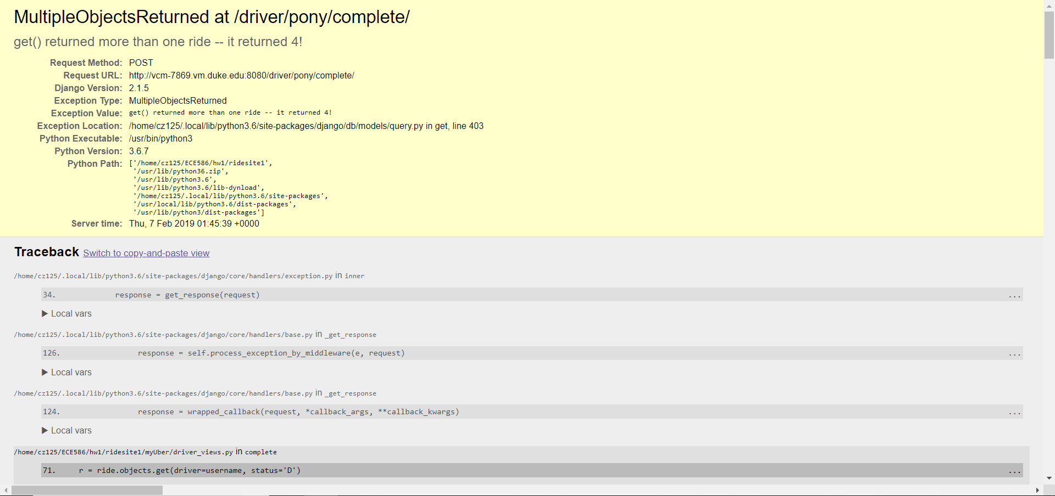

1. ~~If click view confirmed rides and the list is empty:~~

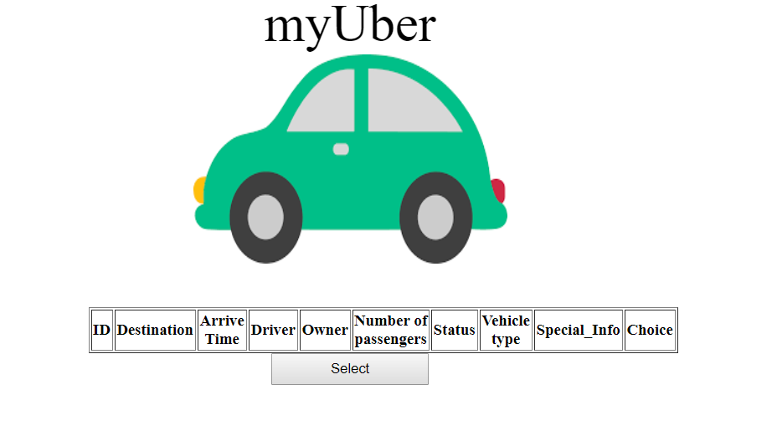

~~Click the button would kill the website:~~ (fixed 2.6)

